“Level Up” Challenge Book List Options:
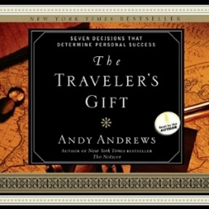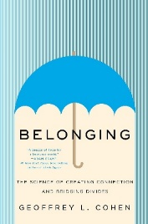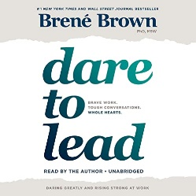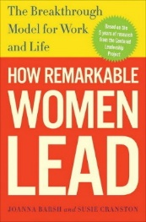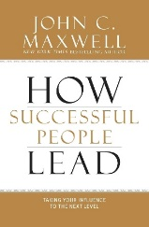

1. The Traveler’s Gift by Andy Andrews
This modern morality tale by gifted writer and speaker Andy Andrews teaches seven fundamental strategies for creating a successful life. Much like the best-selling books by Og Mandino, this unique narrative is a blend of entertaining fiction, allegory, and inspiration. Storyteller Andy Andrews gives a front-row seat for one man's journey of a lifetime. David Ponder has lost his job and the will to live. When he is supernaturally selected to travel through time, he visits historical figures such as Abraham Lincoln, King Solomon, and Anne Frank. Each visit yields a Decision for Success that will one day impact the entire world.
2. The Donkey Principle: The Secret to Long-haul Living in a Racehorse World by Rachel Ann
Ridge
You have what it takes to live well. It’s all about embracing your inner donkey! Some of us feel like do
nkeys in a world that celebrates racehorses―the shiny and flashy success stories that make us question our own worth and abilities. But life isn't about competing for gold medals. It’s about understanding your unique strengths and using them to mine all the gold that’s already within you.
A delightful blend of short reflections, Rachel Anne Ridge’s The Donkey Principle has a central, timely message: Embracing your inner donkey is the key to overcoming obstacles, creating lasting change, and achieving meaningful success. Each chapter of The Donkey Principle includes: memorable stories and practical wisdom that will inspire you to gain new perspective and take action that will unlock your future, ideas to help you discover your own strength and perseverance, and inspiration for moving forward with your personal definition of success

3. “Belonging: The Science of Creating Connection and Bridging Divides” by Geoffrey L. Cohen
Discover the secret to flourishing in an age of division: belonging. In a world filled with discord and loneliness, finding harmony and happiness can be difficult. But what if the key to unlocking our potential lies in this deceptively simple concept? Belonging is the feeling of being a part of a group that values, respects, and cares for us—a feeling that we can all cultivate in even the smallest corners of social life. In Belonging: The Science of Creating Connection and Bridging Divides, Stanford University professor Geoffrey L. Cohen draws on his own and others’ groundbreaking scientific research to offer simple, concrete solutions for fostering a sense of belonging. These solutions can generate surprisingly significant and long-lasting benefits.
Small but powerful actions can bolster belonging—actions such as encouraging people to reflect on their core values before they face a challenge or expressing belief in someone’s capacity to reach a higher standard. A wide range of innovative approaches have been found to boost achievement at work and at school, bridge political divides, reduce prejudice, and even contribute to overall health. Rigorously tested in diverse arenas—from classrooms to disadvantaged neighborhoods to iconic Silicon Valley companies—these methods offer a path forward in these demanding times. Belonging is a compelling read for all who yearn for a more connected world, whether you’re a manager or employee, an educator or student, a parent or caregiver, or simply someone seeking to make the most out of every moment you spend with others. Packed with actionable insights and specific strategies, this book offers hope and practical guidance, serving as both an inspiration and a roadmap to creating a world of inclusion, understanding, and empathy.
4. Dare to Lead by Brene Brown-
Leadership is not about titles, status, and wielding power. A leader is anyone who takes responsibility for recognizing the potential in people and ideas and has the courage to develop that potential.
When we dare to lead, we don’t pretend to have the right answers; we stay curious and ask the right questions. We don’t see power as finite and hoard it; we know that power becomes infinite when we share it with others. We don’t avoid difficult conversations and situations; we lean into vulnerability when it's necessary to do good work.
But daring leadership in a culture that’s defined by scarcity, fear, and uncertainty requires skill-building around traits that are deeply and uniquely human. The irony is that we’re choosing not to invest in developing the hearts and minds of leaders at the exact same time as we’re scrambling to figure out what we have to offer that machines and AI can’t do better and faster. What can we do better? Empathy, connection, and courage, to start. How do you cultivate braver, more daring leaders, and how do you embed the value of courage in your culture? Brown writes, “One of the most important findings of my career is that daring leadership is a collection of four skill sets that are 100 percent teachable, observable, and measurable. It’s learning and unlearning that requires brave work, tough conversations, and showing up with your whole heart. Easy? No. Because choosing courage over comfort is not always our default. Worth it? Always. We want to be brave with our lives and our work. It’s why we’re here.”
5. How Remarkable Women Lead by Joanna Barsh
This book is a hope-filled examination of leadership strategies and opportunities for women and raises “provocative issues such as whether feminine leadership traits (for women and men) are better suited for our fast-changing, hyper-competitive, and increasingly complex world.” She describes Centered Leadership and shares stories from women such as Alondra de la Parra, Andrea Jung, Ruth Porat, Eileen Naughton, and Julie Coates.
Review | “How Remarkable Women Lead is a book that will truly resonate with all women. It is personal, powerful, and revealing and thereby true to how we women live and lead. The storytelling makes this unlike any business book I know; these are people who have faced every challenge imaginable and still made their mark. So truthful, so revealing, it’s a book at once inspirational and practical—a unique duality.” —Elizabeth Smith
6. How Successful People Lead: Taking Your Influence to the Next Level by John C. Maxwell Leadership influence is not generated by your title. In fact, being named to a position is the lowest of the five levels every effective leader achieves. To be more than a boss people are required to follow, you must master the ability to inspire and invest in people. You need to build a team that produces not only results, but also future leaders. By combining the advice contained in these pages with skill and dedication, you can reach the pinnacle of leadership—where your influence extends beyond your immediate reach for the benefit of others.

